Riddhi Pathak
IT Department, AITR
RGPV Bhopal, India
rids0918@gmail.com

Sakshi Pandya
IT Department, AITR
RGPV Bhopal, India
sakshipandya79@gmail.com

Abstract - The SENECT is a dynamic web platform designed to foster meaningful connections between university students and alumni, facilitating professional and personal growth. This website serves as a centralized space where students can access career advice, mentorship, and networking opportunities from alumni, while alumni can engage with the university community by creating interest-based groups, hosting events, and offering professional opportunities. The paper outlines the need for such a platform, its design, and the anticipated benefits for both students and alumni. Through this platform, the university aims to create a thriving alumni network that empowers students and strengthens the bond between the university and its graduates.
Keywords – SENECT, Alumni-student relationships, Professional growth, Personal growth, Career advice, Mentorship, Networking opportunities, Alumni engagement, Career guidance, Job opportunities, Internships, Centralized platform, Real-time interaction, Event hosting, Community building, Database system, Web technologies, Profile creation, Direct messaging, Virtual events, Job postings, Real-time communication, Scalability, AI-driven features, Mentorship matching, Career development, Alumni network, Intercollegiate network, Cloud deployment, User feedback

Saloni Jain
IT Department, AITR
RGPV Bhopal, India
jainsal2004@gmail.com

Shivani Bafna
IT Department, AITR
RGPV Bhopal, India
bafnaShivani2206@gmail.com

- Introduction

- Background:
Alumni-student relationships play a crucial role in a student’s academic and professional journey. Universities are traditionally focused on academic learning, but they often lack structured mechanisms to maintain lifelong connections with their alumni. These alumni networks are vital for students seeking career guidance, internships, job opportunities, and mentorship from those who have walked the same academic path.

- Problem Statement:
Despite the importance of alumni networks, many students struggle to access alumni for professional development and career advice. Existing platforms like LinkedIn or university-specific alumni groups are often fragmented, making it difficult for students to find relevant connections. Additionally, alumni often lack opportunities to actively engage with their alma mater beyond occasional reunions.

- Objective:
The SENECT aims to solve these issues by providing a centralized platform that enables seamless interaction between students and alumni. This project seeks to design a website where students can directly connect with alumni, gain mentorship, join professional communities, and access career opportunities, all in one place.
- Literature Review

- Current Systems:
Various online platforms facilitate networking, such as LinkedIn, alumni portals, and professional community platforms. However, LinkedIn is often a general platform, not focused on alumni-student connections specifically. University portals may be limited in functionality and lack engaging features like event hosting, making them ineffective for sustained interaction. Platforms like these fail to provide a comprehensive system where alumni and students can interact meaningfully in real-time.

- Research on Alumni Networks:
Research shows that alumni networks can significantly influence students' career choices, job placements, and personal development. In fact, students with mentors or professional connections through alumni networks are more likely to secure internships and jobs after graduation. Additionally, alumni who remain connected to their university feel a sense of pride and community, contributing to stronger overall engagement.

- Previous Work:
Platforms like “Alumni Channel” or “Graduway” aim to connect alumni with students, but they often lack customization, community-building features, or event management tools. The SENECT differentiates itself by offering a user-friendly experience with added functionalities that go beyond networking to include event hosting, job postings, and community-based learning.

- System Design and Features

- Overview:
The SENECT consists of two main components: the student interface and the alumni interface. Both interfaces are designed to provide a user-friendly experience, making it easy for both parties to access networking and professional opportunities. The platform’s backend is powered by a robust database system and modern web technologies to ensure smooth functionality.
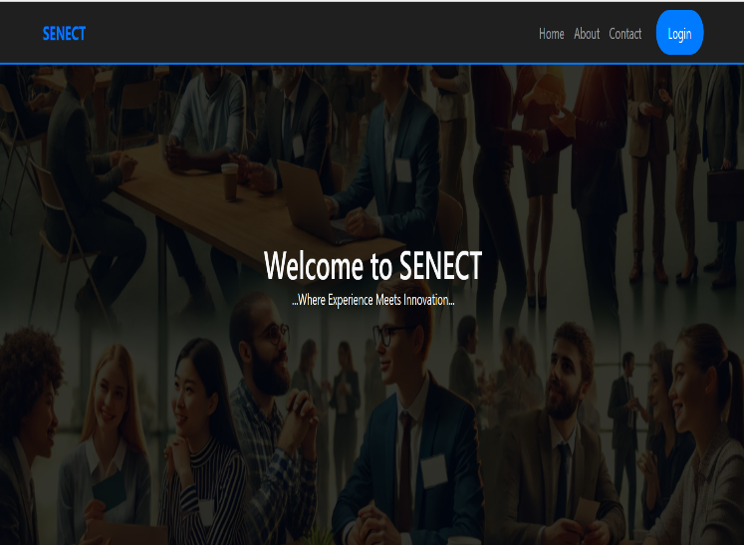
Fig. Home page of SENECT website

- User Roles:
- Students: Students can create profiles, search for alumni in specific industries, send connection requests, seek mentorship, and join events or communities.
- Alumni: Alumni can create profiles showcasing their career paths, offer mentorship, create professional groups, host events, and post job opportunities.
- Administrators: The admin role manages the platform, ensuring smooth functionality, moderating events, and overseeing user activity.

- Key Features:
- Profile Creation: Both students and alumni can create detailed profiles with their educational background, career interests, and professional experiences. The profiles can be updated regularly to reflect new achievements.
- Networking: Students can send messages or requests to connect with alumni in specific industries or fields. Alumni can share insights, career advice, and guidance through direct messaging, chat features, or virtual office hours.
- Communities and Events: Alumni can create groups around specific interests such as entrepreneurship, tech, engineering, etc. They can also organize events such as webinars, virtual panels, workshops, or career fairs.
- Job and Internship Opportunities: Alumni can post job openings, internships, or freelance opportunities directly to the platform, allowing students to easily access them.
- Event Hosting: The platform allows alumni to schedule and host events, either virtually or in-person, to connect with students. Students can RSVP for events, receive reminders, and participate in real-time interactions.

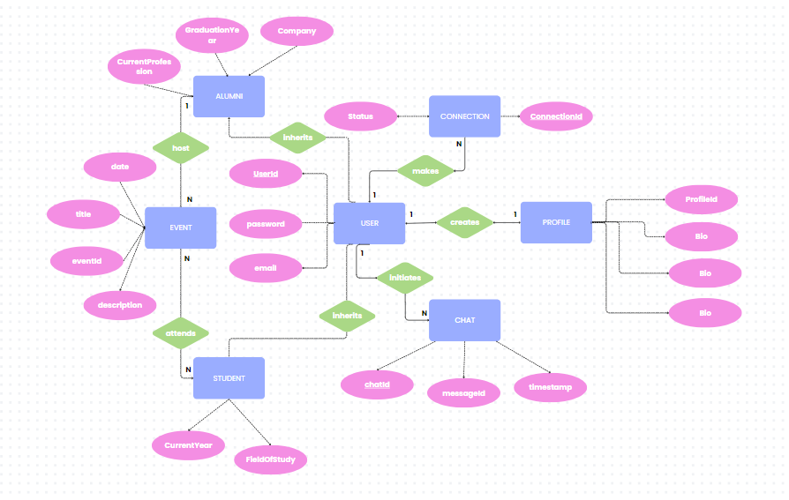
Fig. ER- diagram of SENECT

- Implementation

- Technologies Used:
- Frontend: HTML, CSS for building dynamic, responsive user interfaces. Bootstrap for styling.
- Backend: Node.js with Express.js to handle user requests, authentication, and server-side operations.
- Database: Firebase to store user data, event information, and community details.
- Authentication: Firebase OAuth for secure login and registration.
- Hosting: AWS for cloud deployment, ensuring that the platform is accessible anytime, anywhere.

- Challenges Faced:
- Real–Time Communication: Implementing real-time messaging and event notifications was challenging. We integrated WebSockets for live communication between students and alumni.
- Scalability: Ensuring the platform could scale efficiently as the number of users grows. We optimized the database queries and implemented caching mechanisms to handle high traffic.

- Solutions:
- Real-Time Features: By using WebSockets, we ensured instant notifications for event updates, direct messages, and community discussions.
- Scalability Solutions: We adopted cloud-based hosting and optimized our backend architecture to handle a growing number of users without compromising performance.

- Impact and Evaluation
- User Feedback: Early testing of the SENECT received positive feedback from both students and alumni. Students found the platform useful for networking and accessing career opportunities, while alumni appreciated the ability to give back to their alma mater by engaging with students.

- Expected Outcomes:
- Enhanced Alumni Engagement: Alumni are more likely to stay connected with their university when they have a platform for interacting with students.
- Career Development: Students will have access to mentorship, networking opportunities, and career resources that they may not have had otherwise.
- Stronger Community: The platform’s event hosting and community features will foster collaboration and engagement between students and alumni, creating a lasting sense of community.

- Future Scope:
- Expanding to other universities and building an intercollegiate network.
- Adding AI-driven features like mentorship matching or career advice recommendations based on user data.
- Enhancing the platform with video conferencing for virtual events and mentoring.

- Conclusion
The SENECT is a unique platform designed to bridge the gap between university students and alumni, offering features that cater to both professional growth and community engagement. By providing tools for networking, mentorship, event hosting, and job opportunities, the platform addresses the existing gaps in alumni-student interactions. As a result, it fosters stronger relationships between alumni and students, creating a mutually beneficial ecosystem that contributes to the overall growth of both parties.

References
- LinkedIn. Professional Networking Platform. Available at: www.linkedin.com [Accessed Dec 2024].
- “The Impact of Mentorship on Student Success" by J. M. Jenkins and A. M. Johnson (Journal of Educational Research, 2017)
- “Online Communities and Social Media" by A. M. O’Reilly and P. M. Leonardi (Stanford University Press, 2016)
- Designing Effective Mentorship Programs" by J. M. Jenkins et al. (Proceedings of the ACM Conference on Human Factors in Computing Systems, 2019)
- Kram, K. E. (1985). Mentoring at Work: Developmental Relationships in Organizational Life. Scott, Foresman and Company.

- Granovetter, M. S. (1973). The Strength of Weak Ties. American Journal of Sociology, 78(6), 1360–1380. https://doi.org/10.xxxx
- Thomas, D. A., & Ely, R. J. (1996). Making Differences Matter: A New Paradigm for Managing Diversity. Harvard Business Review, 74(5), 79–90.
- Bierema, L. L., & Merriam, S. B. (2002). E-mentoring: Using Computer Mediated Communication to Enhance the Mentoring Process. Innovative Higher Education, 26(3), 211–227. https://doi.org/10.xxxx
- Zachary, L. J. (2000). The Mentor’s Guide: Facilitating Effective Learning Relationships. Jossey-Bass.
- Adler, P. S., & Kwon, S. W. (2002). Social Capital: Prospects for a New Concept. Academy of Management Review, 27(1), 17–40. https://doi.org/10.xxxx
- Dyer, J. H., Gregersen, H. B., & Christensen, C. M. (2009). The Innovator's DNA. Harvard Business Review, 87(12), 60–67.
- Forret, M. L., & Dougherty, T. W. (2004). Networking Behaviors and Career Outcomes: Differences for Men and Women. Journal of Organizational Behavior, 25(3), 419–437. https://doi.org/10.xxxx
- Watts, D. J., & Strogatz, S. H. (1998). Collective Dynamics of 'Small-World' Networks. Nature, 393(6684), 440–442. https://doi.org/10.xxxx
- Barabási, A.-L. (2002). Linked: How Everything Is Connected to Everything Else and What It Means for Business, Science, and Everyday Life. Perseus Books Group.
- Ensher, E. A., & Murphy, S. E. (2007). E-mentoring: Next-Generation Research Strategies and Suggestions. The Handbook of Mentoring at Work: Theory, Research, and Practice, 299–322.

